FOR IMMEDIATE RELEASE

Contact:
Sheryl Barr
Marketing Analyst
609-528-3884
sheryl.barr@rtspecialty.com

RT New Day Named One of the Best
Places to Work in New Jersey by NJBIZ Magazine

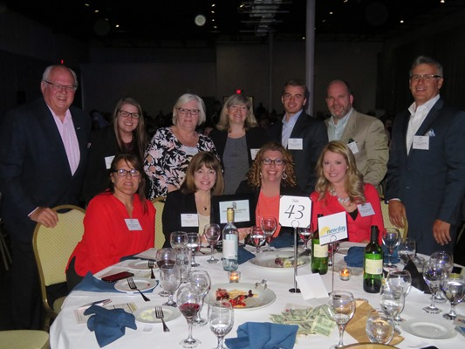
HAMILTON, NJ (May 16, 2018) – RT New Day (formerly New Day Underwriting Managers), a part of R-T Specialty, LLC, has once again been named one of the Best Places to Work in New Jersey by NJBIZ Magazine. During ceremonies held May 1st at iPlay America's Event Center in Freehold, NJ, RT New Day was ranked 19th in the small business category for the company’s ongoing dedication to employee professional growth and quality of life.

“This is the fourth time we’ve been honored with this distinction in the past five years,” says Jefferey S. Lejfer, CPCU, RT New Day’s president. “Our goal has always been to grow the company with the very best people. We’ve done this by striving each and every year to provide the optimal work and learning experience to our staff. Their professional and personal development is at the forefront of our success.”

“We’ve spent the past 14 years dedicated to our customers, staff and the industry at large,” says Lejfer. “Their best interests form the basis of every business decision we’ve ever made. Our growth and continued expansion would not have been possible without their perseverance and our commitment to a work environment that fosters success and quality to every stage of life.”

Earlier this year, New Day expanded this mission when it became part of R-T Specialty, LLC (RT Specialty), the wholesale brokerage unit of Ryan Specialty Group. Combining with RT Specialty strengthened their offerings in the environmental, construction and real estate marketplace, while extending New Day’s reach in the construction and real estate industries. Since its founding in 2005, RT New Day (formerly New Day Underwriting Managers) has grown from a three-person organization to an award-winning, specialty intermediary of environmental and construction-related professional liability insurance coverages.

The Best Places to Work in New Jersey program, created in 2005, was produced by NJBIZ in partnership with Garden State Council SHRM and the Employers Association of New Jersey. It was designed to identify, recognize and honor the top places of employment in New Jersey that benefit the state's economy. The two-part selection process consists of employee surveys and an evaluation of each company’s workplace policies, practices, philosophy, systems and demographics.

To learn more about RT New Day products and services please visit newday.rtspecialty.com or call 609.298.3516.

About R-T Specialty, LLC
RT New Day*, a division of R-T Specialty, LLC, is a specialty resource for agents and brokers, assisting them and their clients find appropriate, high-quality environmental and construction-related professional liability insurance coverages. R-T Specialty, LLC (RT), a subsidiary of Ryan Specialty Group, LLC, provides wholesale brokerage and other services to agents and brokers. RT is a Delaware limited liability company based in Illinois. In California: R-T Specialty Insurance Services, LLC License #0G97516. www.rtspecialty.com

* Announced April 2, 2018.

# # # #

